1. Install create-react-app globally if it is not installed, If you install NodeJS it will be there automatically
   1. 
2. Create demo app with below command
   1. 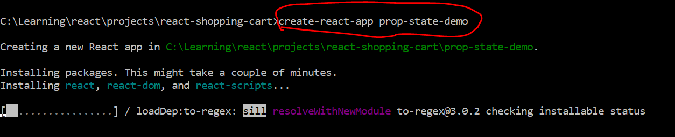
3. Go thru Project structure if required and default page
4. Create Counter component
   1. 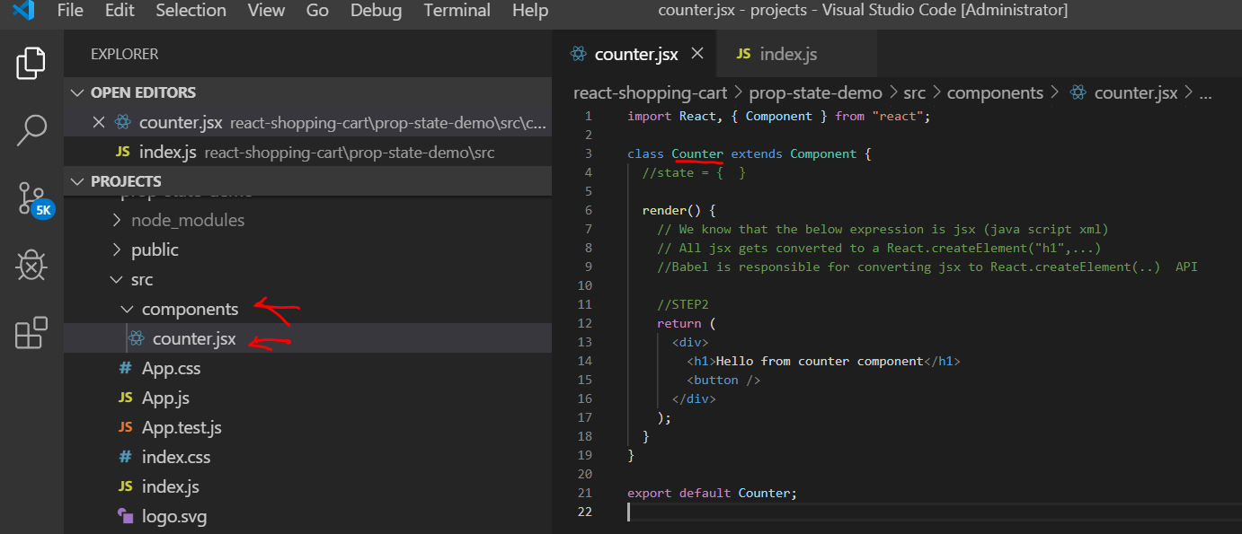
   2. Code

import React, { Component } from "react";

class Counter extends Component {

//state = { }

render() {

// We know that the below expression is jsx (java script xml)

// All jsx gets converted to a React.createElement("h1",...)

//Babel is responsible for converting jsx to React.createElement(..) API

//STEP2

return (

<div>

<h1>Hello from counter component</h1>

<button />

</div>

);

}

}

export default Counter;

1. Make below changes in index.js
   1. 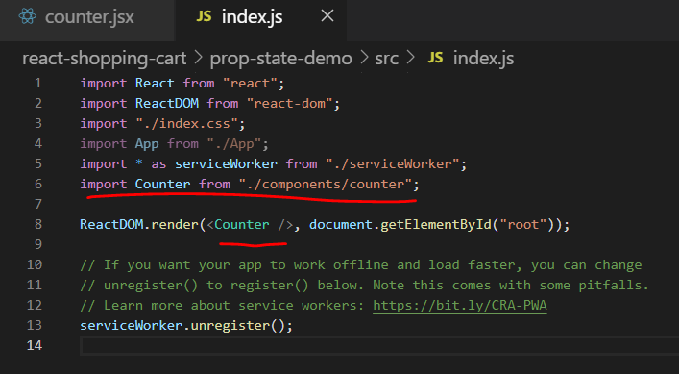
   2. 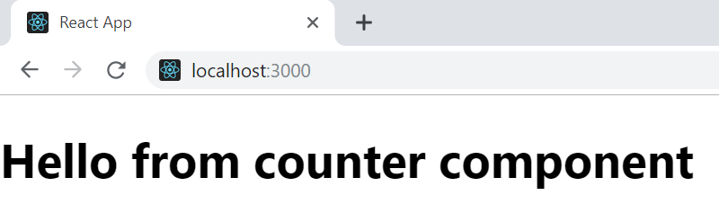
2. Add Bootstrap  
   1. 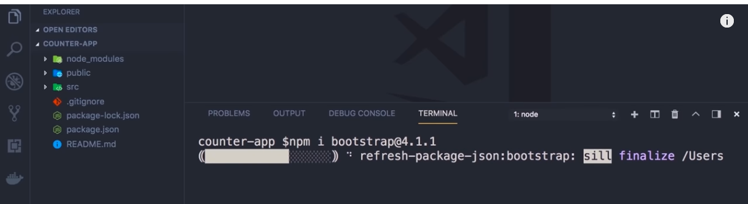

import "bootstrap/dist/css/bootstrap.css";

1. Create a click button with counter and show access to state when it is possible and when not
   1. 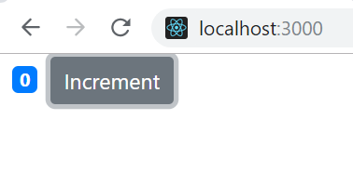
   2. Code

import React, { Component } from "react";

class Counter extends Component {

state = {

count: 0

};

render() {

return (

<div>

<span className="badge badge-primary m-2">{this.state.count} </span>

<button

onClick={this.handleIncrement}

className="btn btn-secondary btn-sm"

>

Increment

</button>

</div>

);

}

}

export default Counter;

* 1. Add an On increment button click event handler and try to access state
  2. Code

//we do not have access to state

handleIncrement() {

console.log("Increment Clicked", this.state.count);

}

* 1. Below error
     1. 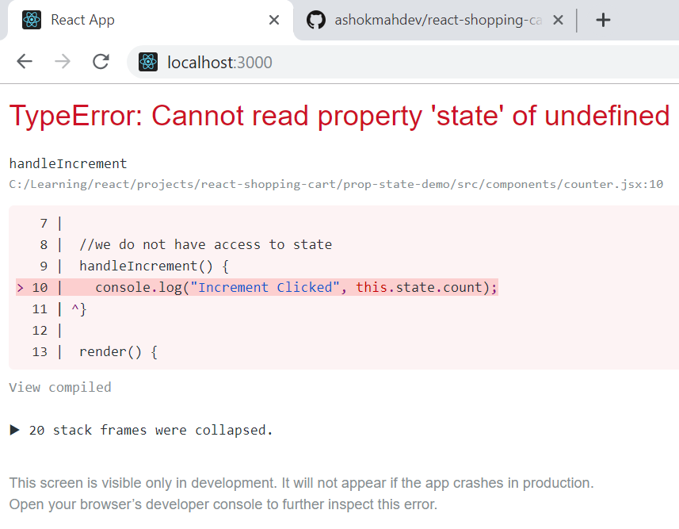
     2. Fix it by converting it to any arrow function

handleIncrement = () => {

console.log("Increment Clicked", this.state.count);

};

* 1. Lets try to increment the counter and observe
  2. Now we have access to the state and we can increment the counter which is not going to work. This is because technically the counter is increasing but the react is not aware of it. We have explicitly tell react that the state has changed (we basically tell virtual DOM). After that the react will update the DOM(not virtual). In angular the change detection is automatic because they are monkey patched.

this.state.count++;

* 1. Click on increment and observe that DOM is not getting updated
     1. 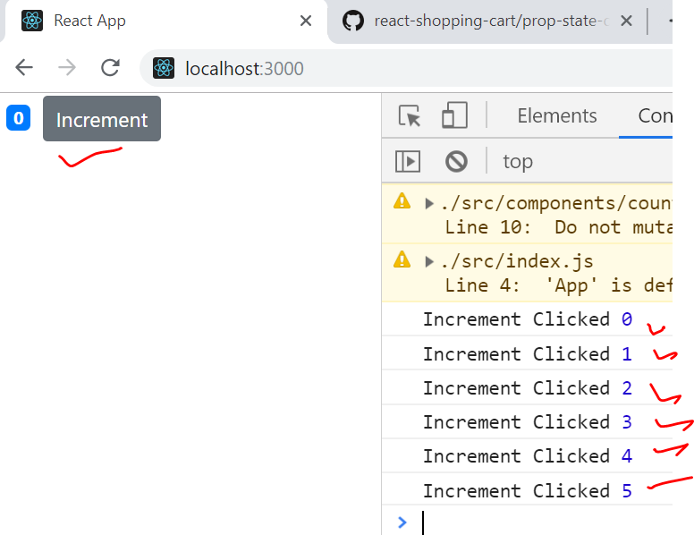
  2. We have to explicitly tell react about what part of the state is changed using below API

this.setState({ count: this.state.count + 1 });

* 1. OBSERVR IN DOM ONLY THE SPAN CHANGING
     1. 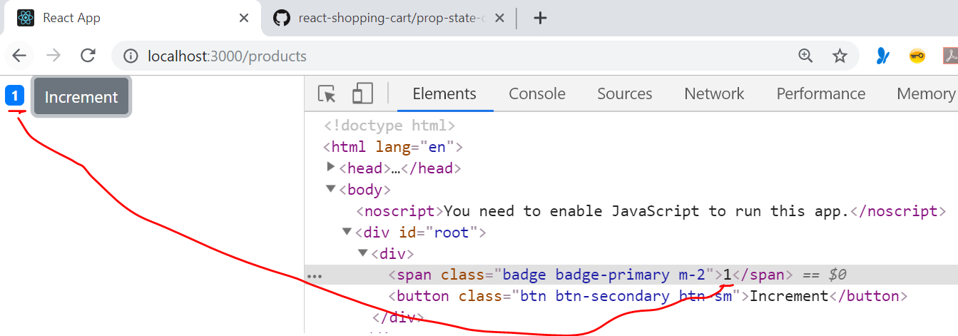

1. 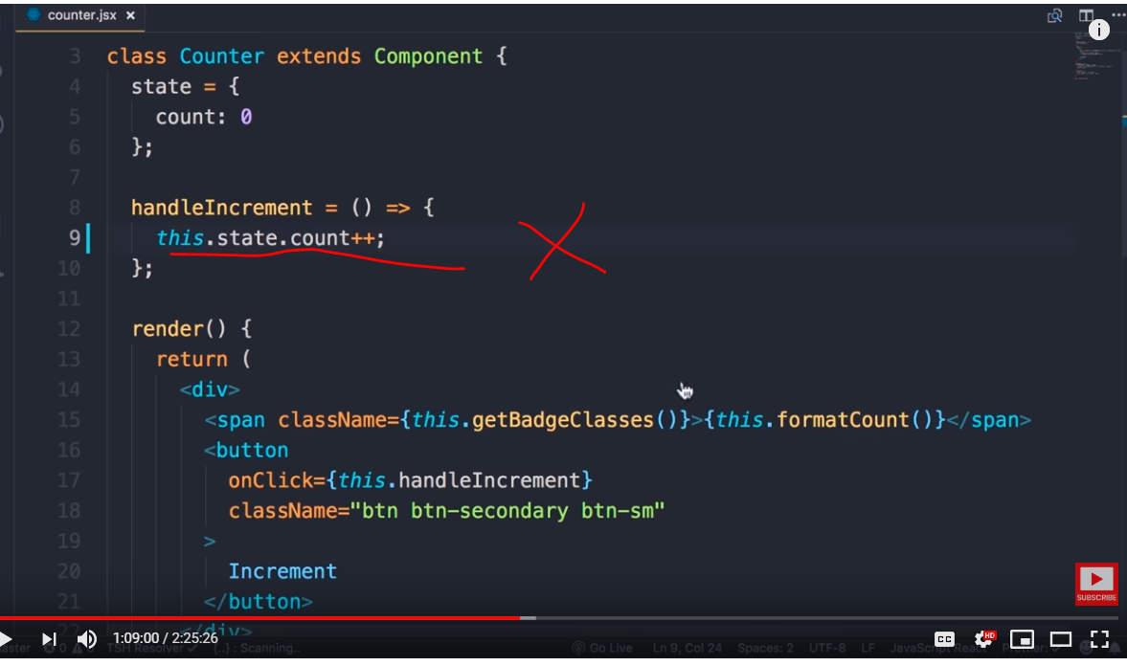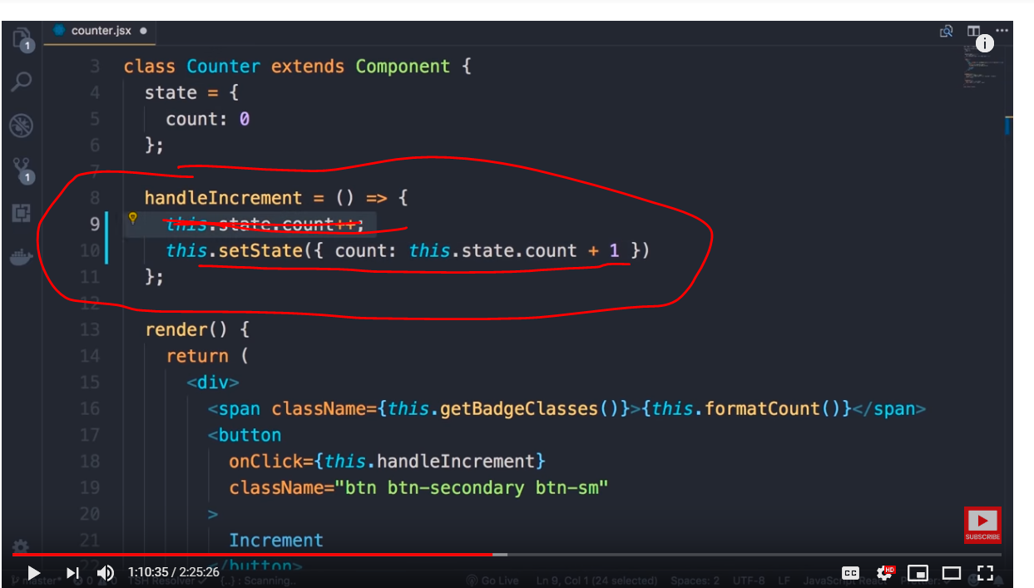



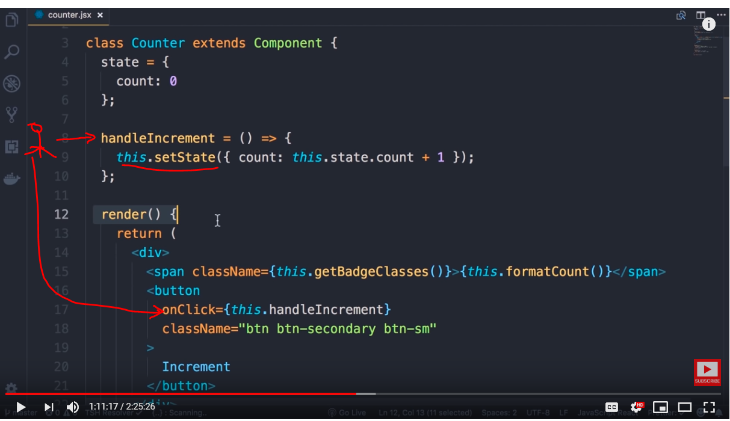

1. User clicks on the increment button
2. The click handler changes the state and informs react about change in state
3. React is going to schedule a call to render() method and we do not know when , it could be 5 ms later or 10ms later
4. 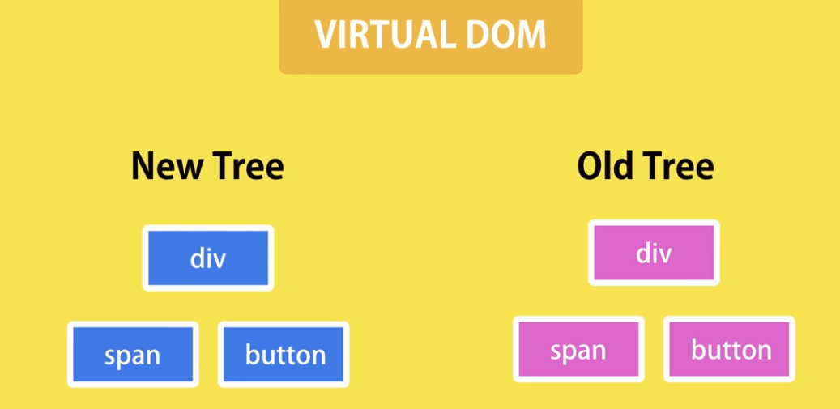

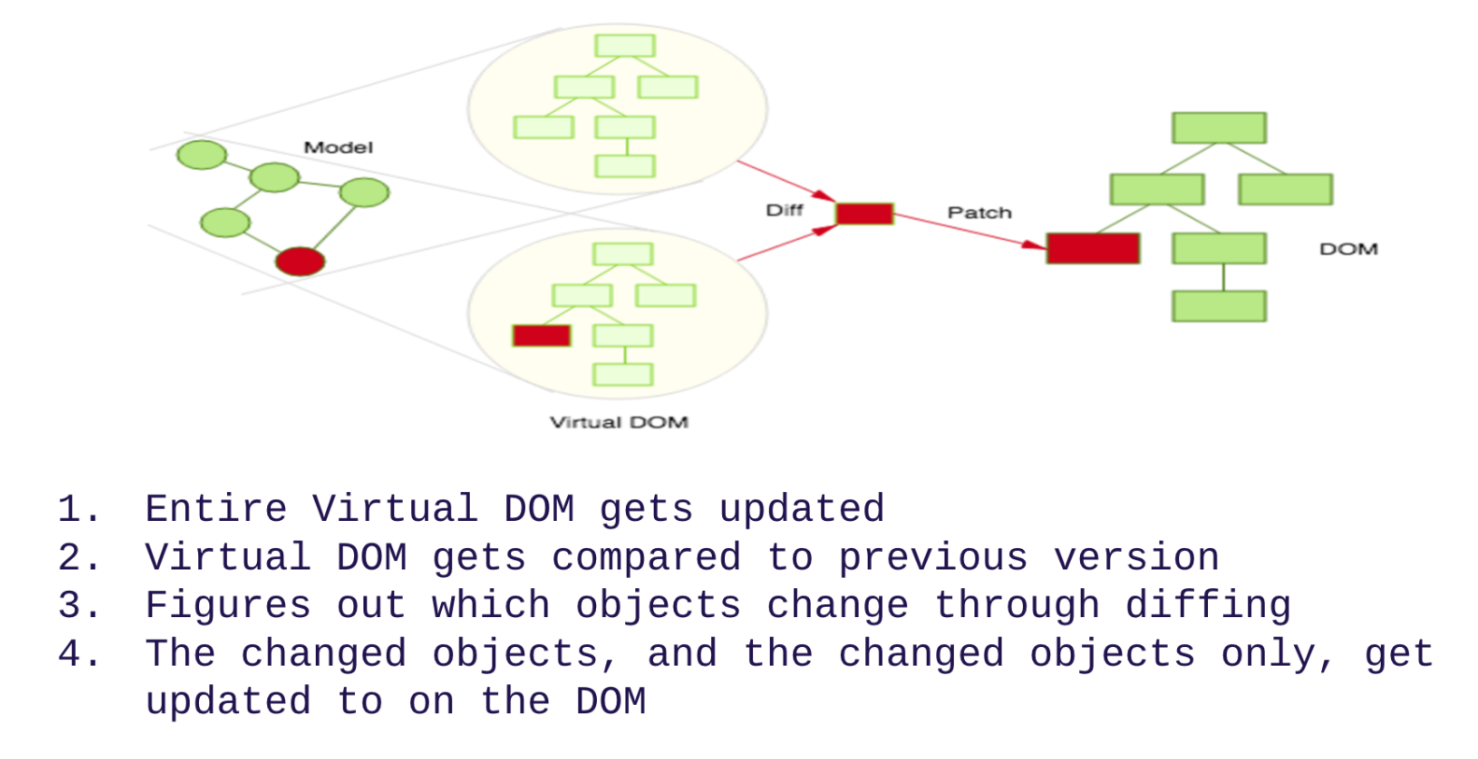

1. In our case it realizes that only span value has changed
2. React reaches the actual DOM and modifies only span value and nothing else in DOM is affected

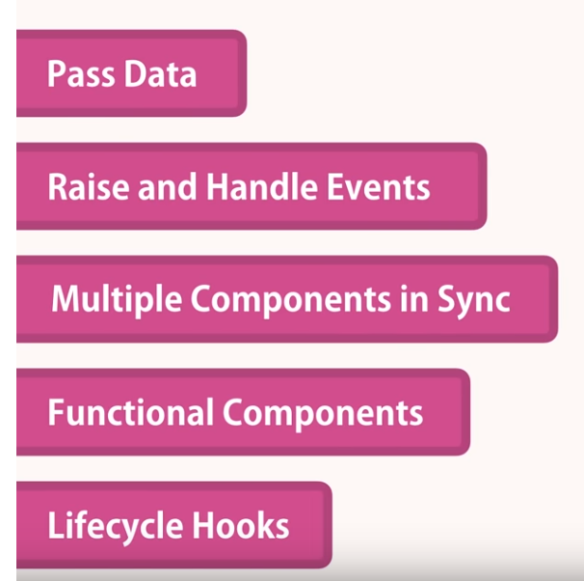

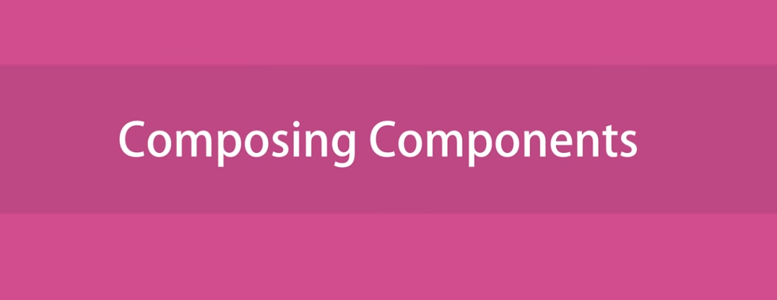

1. Now let’s implement Counters component having list of counters and register it in index.js
   1. 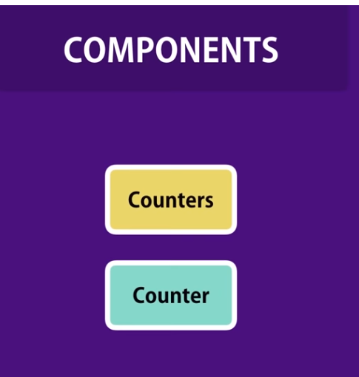
   2. Code

import React, { Component } from "react";

import Counter from "./counter";

class Counters extends Component {

state = {

counters: [

{ id: 1, value: 0 },

{ id: 2, value: 0 },

{ id: 3, value: 0 },

{ id: 4, value: 0 }

]

};

render() {

return (

<div>

{this.state.counters.map(counter => (

<Counter key={Counter.id} />

))}

</div>

);

}

}

export default Counters;

* 1. Include the counters component in index.js
     1. 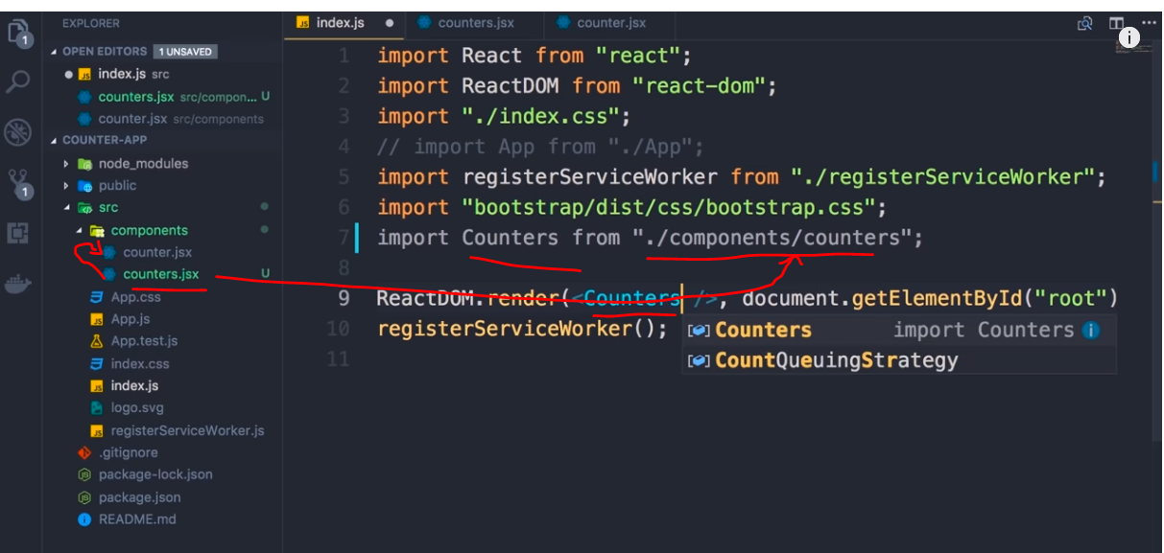
  2. Each component has its own state that is completely isolated from each other
  3. 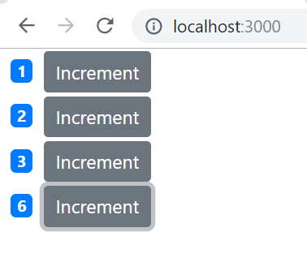



This is how we set the value

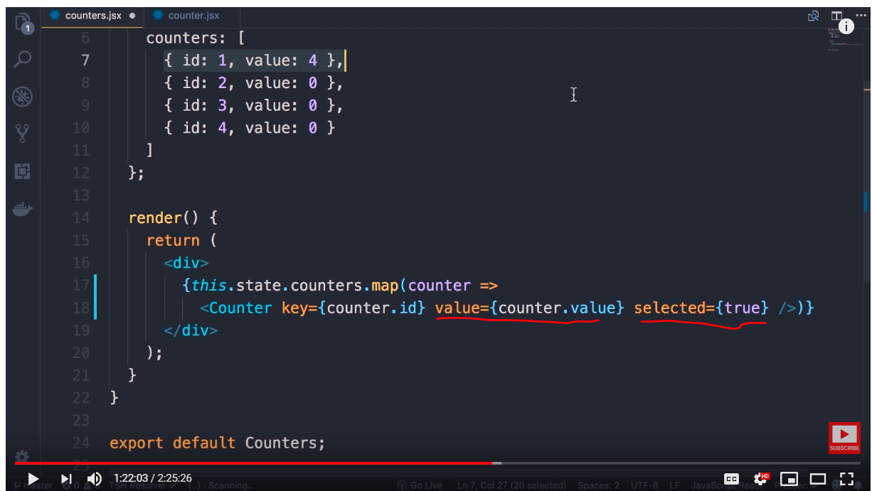

In the above example we are setting attributes and values to the counter component

Lets add console log inside the child component to print the attribute values passed by parent component

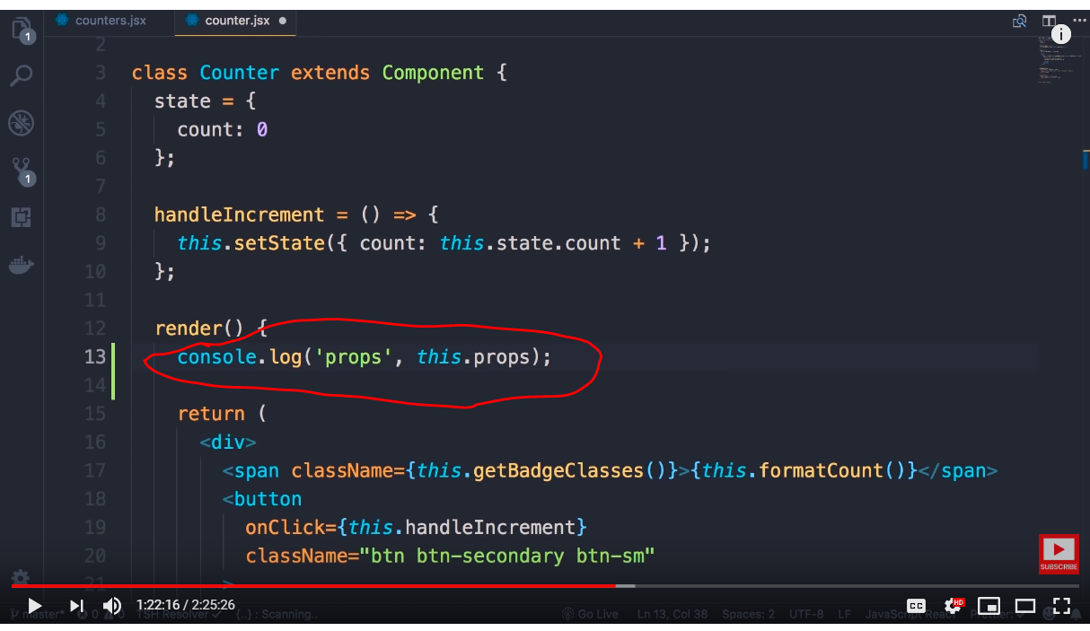

Props is a default property of every react component which holds all attributes and its values for the component

Note : Key attribute will not be part of it as it is a special attribute for uniqueness

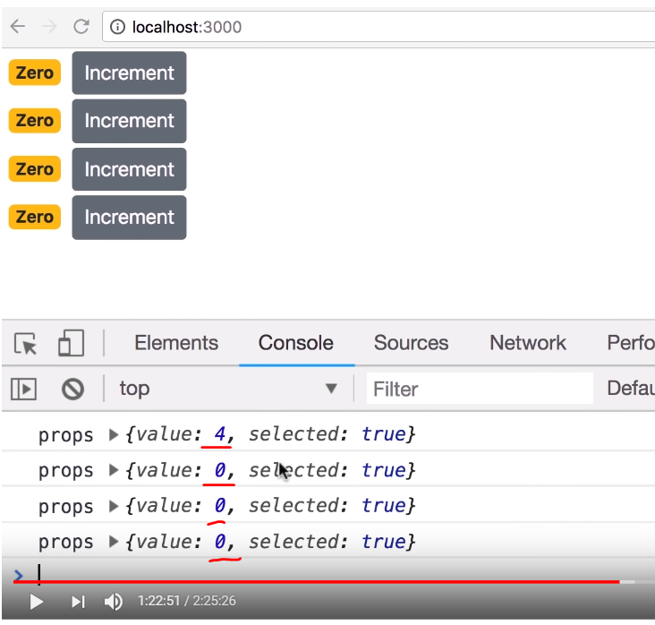

Porps is a plain java script object

Note : we are able to print the attribute values passed by parent , it is still not assigned to the child component state , we do that using below syntax

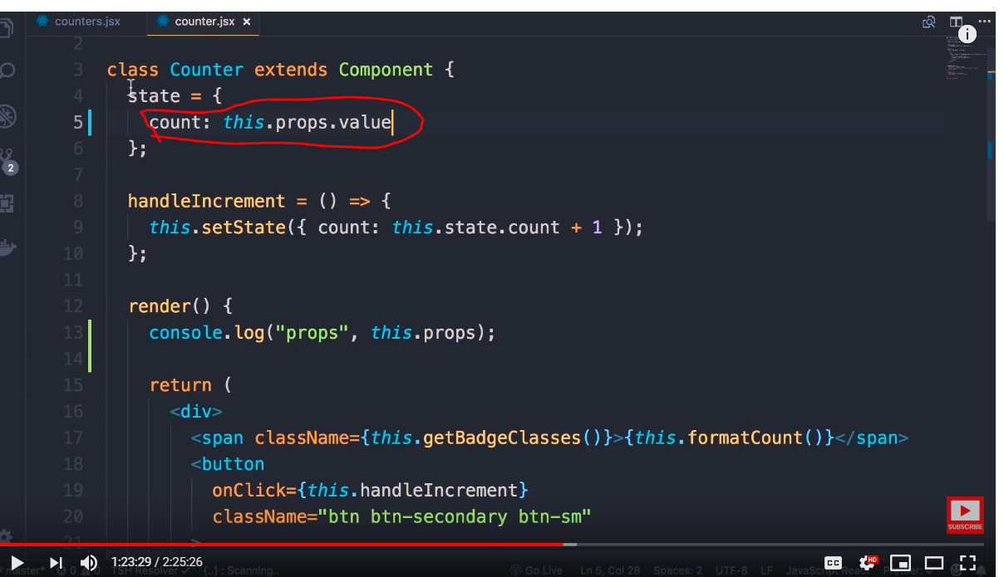



Install react developer tools extensions for chrome

We can see props and state of each component

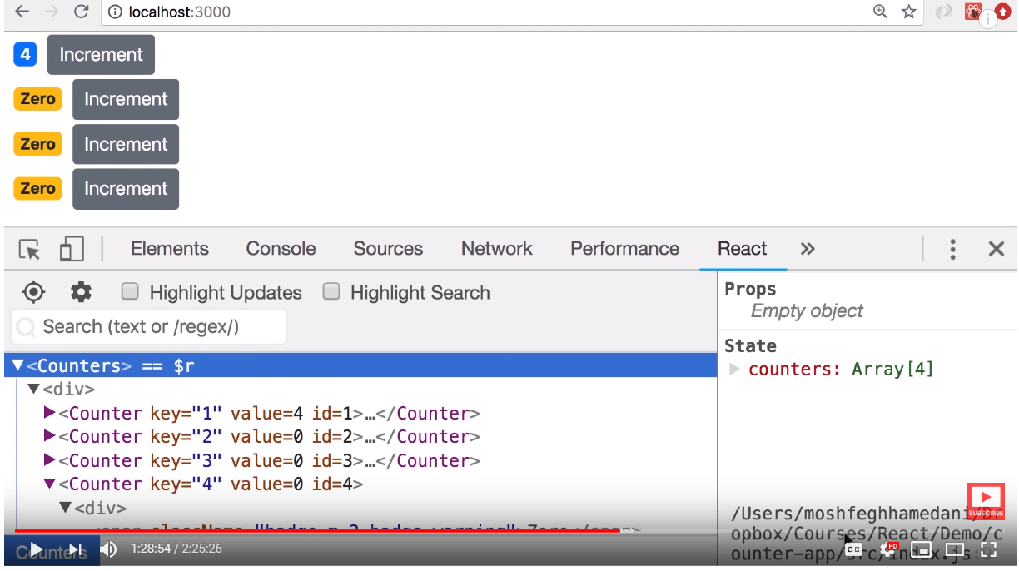

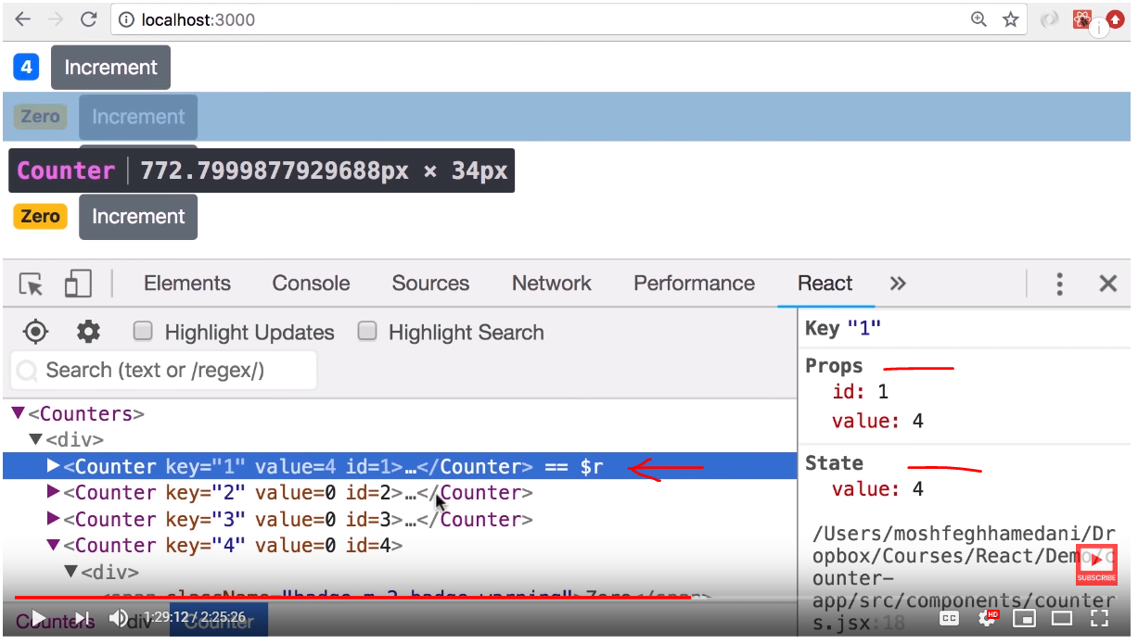

For complex pages we can simply search the component

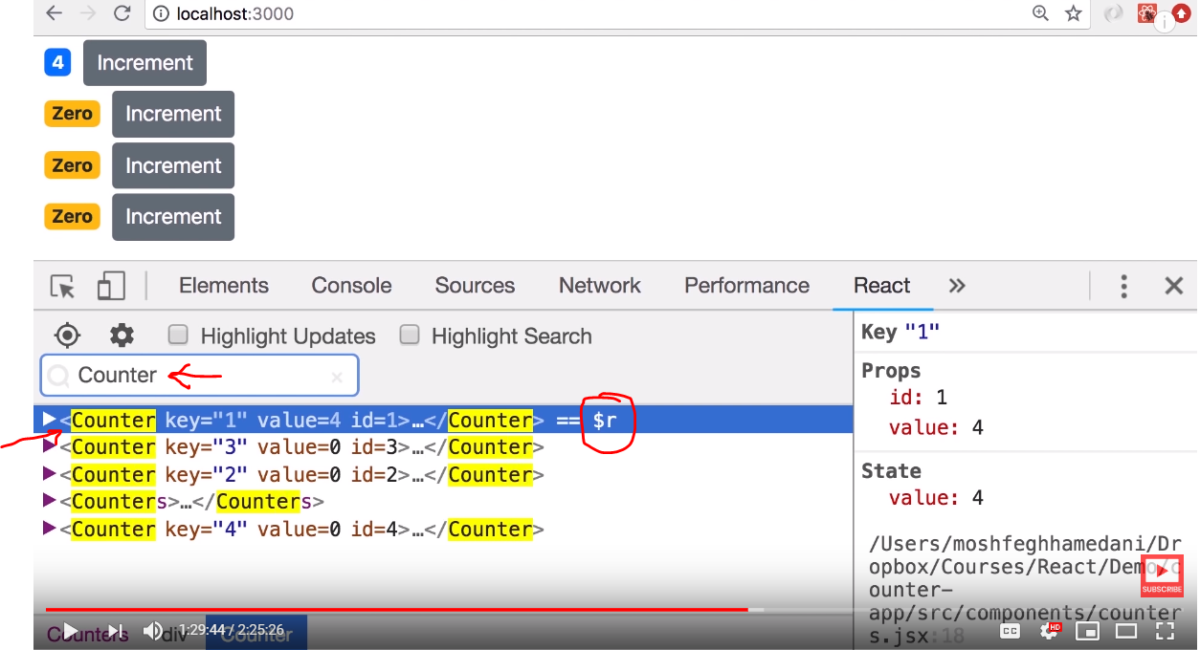

Another useful feature is , notice $r as we select each component

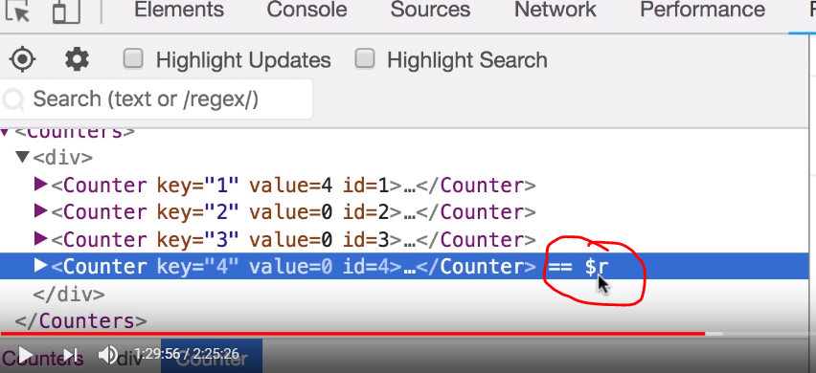

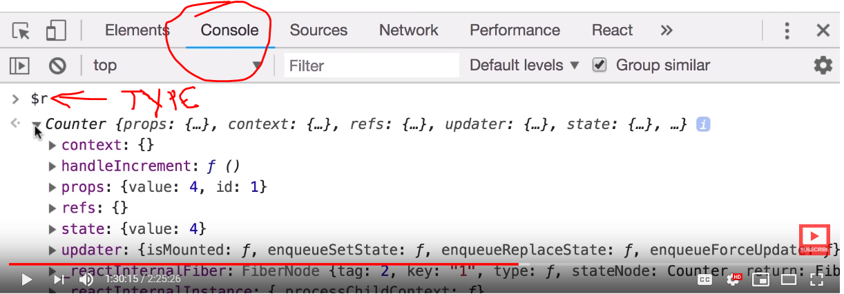

If we type $r in console we get the instance of the component

$r.render() will get react element itself

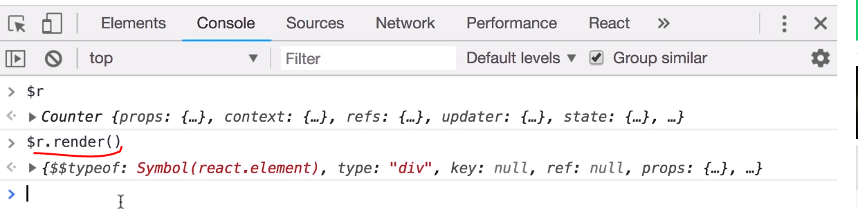

Another feature

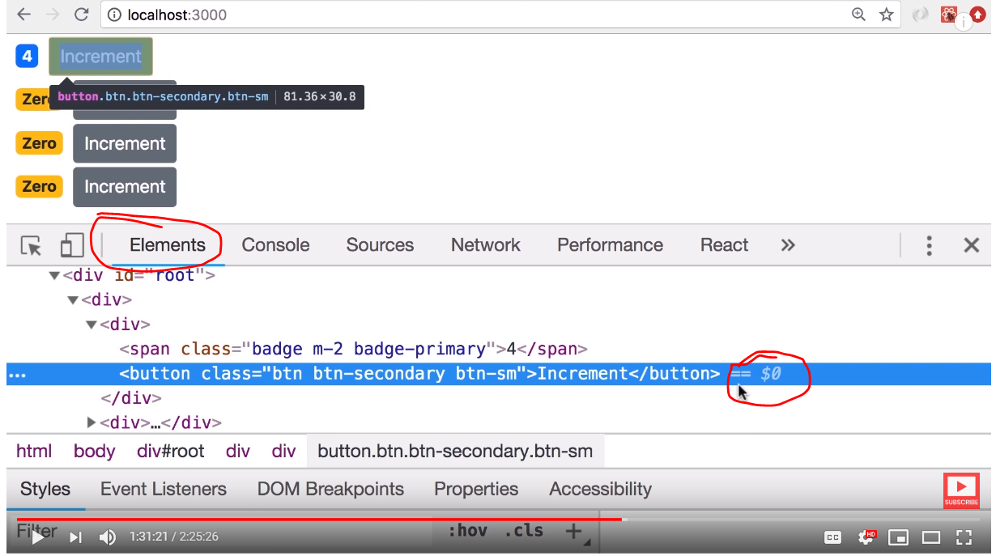

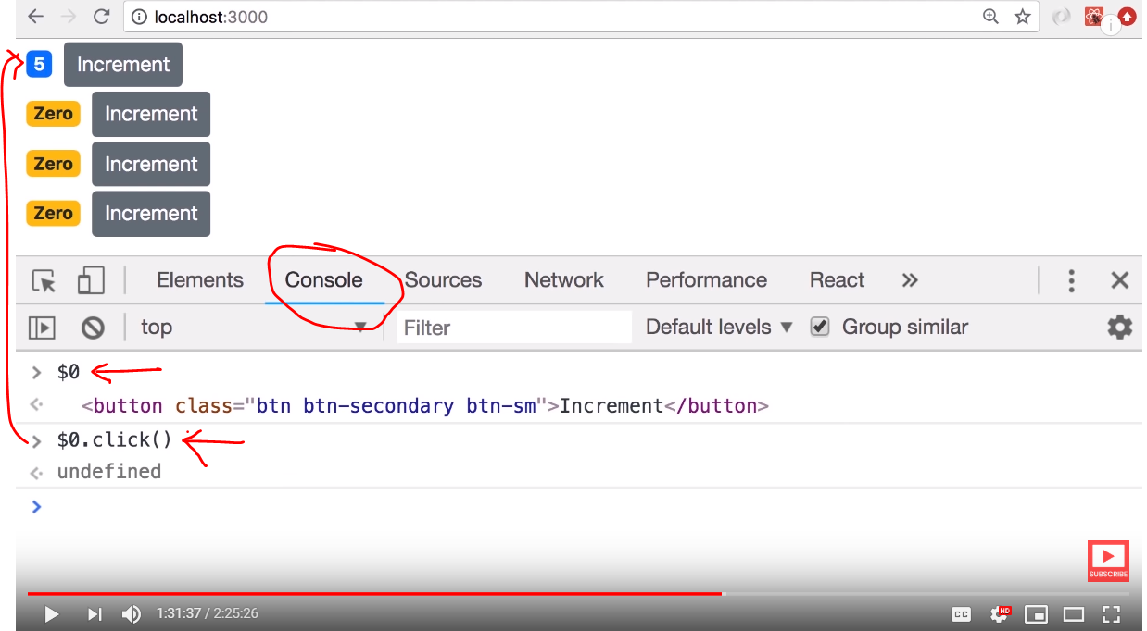 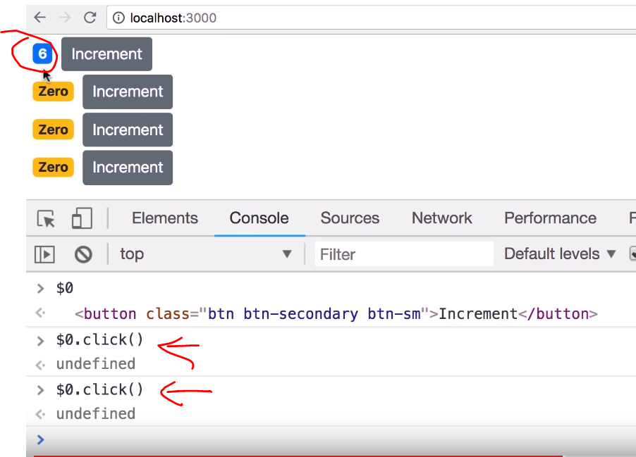

We can imitate the click event of individual component in developer tools

This way react makes building components and debugging very easy



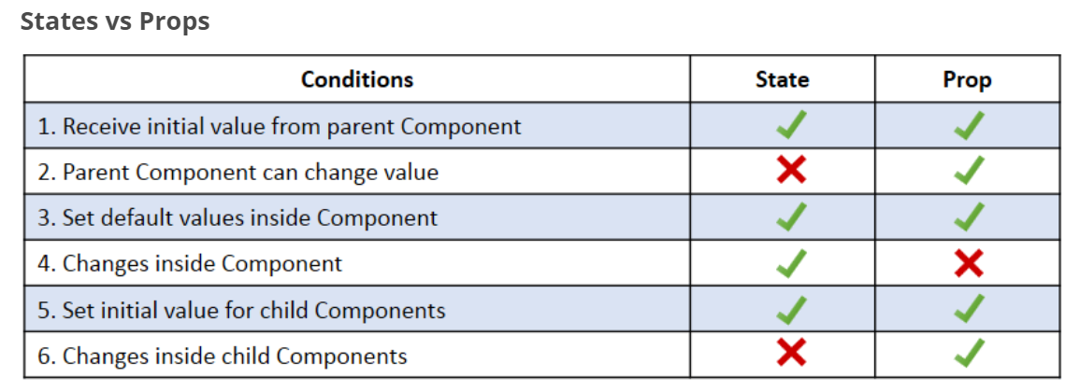

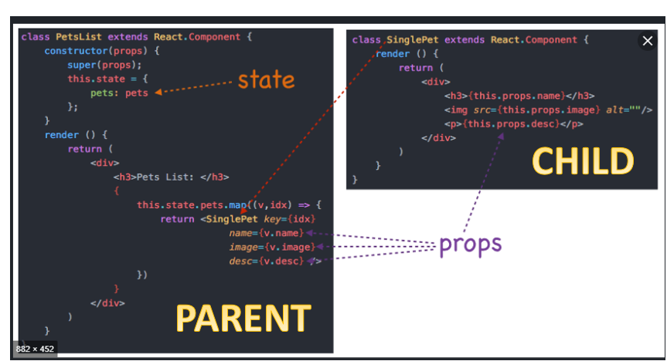

Props – The data we give it to the component

State – The local data or private data of the component

The state can not be accessed from outside , state is internal to the component

Props is read only, we can not change the prop value inside the component

Example : try to change the value of a prop as shown below and click the increment button, then see the error

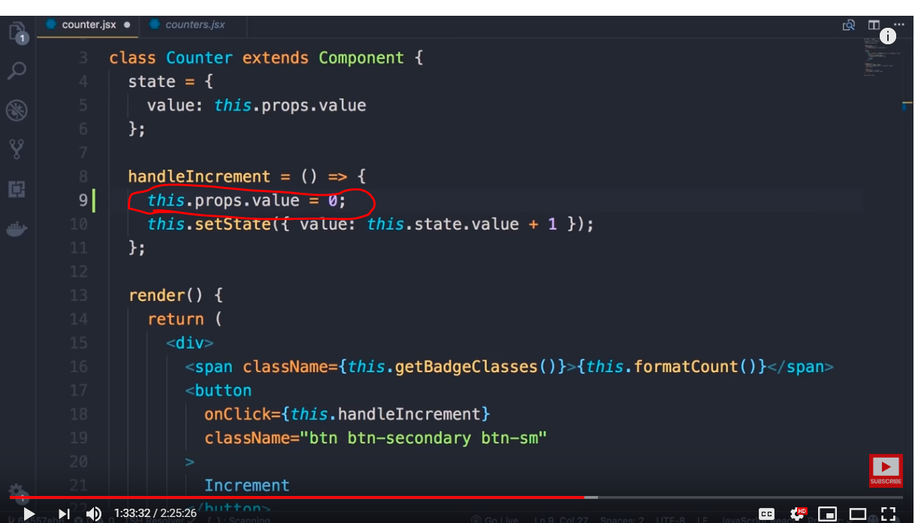 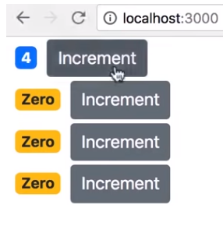

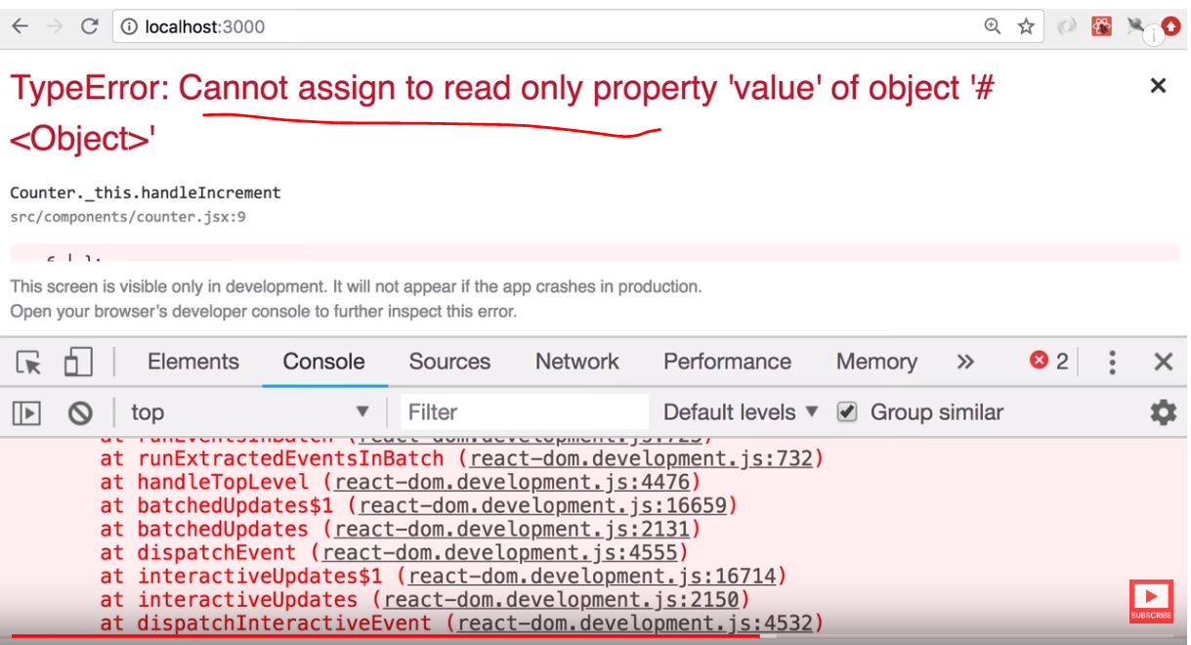

We can assign the prop value to state and modify

**Next lets look at raising and handling events**

Lets add a delete button to the component

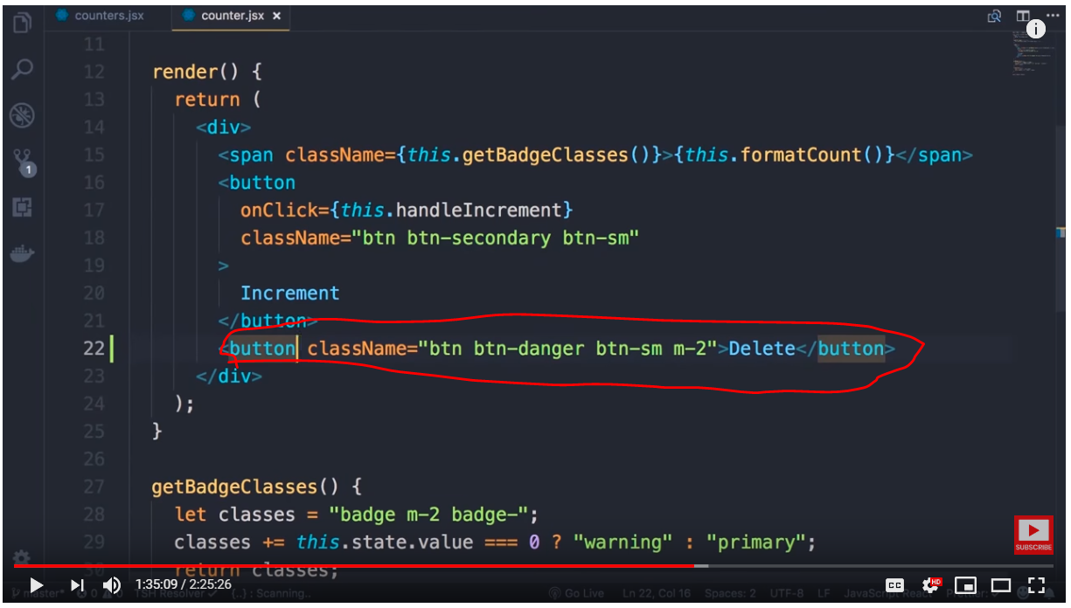 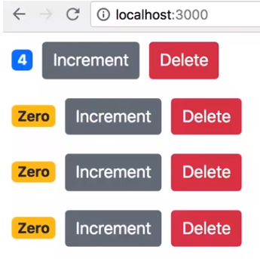

Code for adding delete button

<button className="btn btn-danger btn-sm m-2">Delete</button>

If you observer the child component ( counter component) has only value, if we need to delete the entire counter which is owned by parent conuters component , we need to inform parent component which owns the state of entire list of counters (from which the selected counter needs to be deleted)

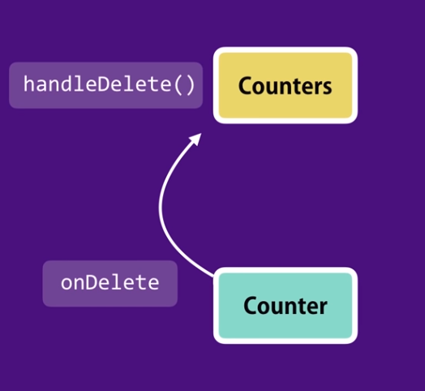

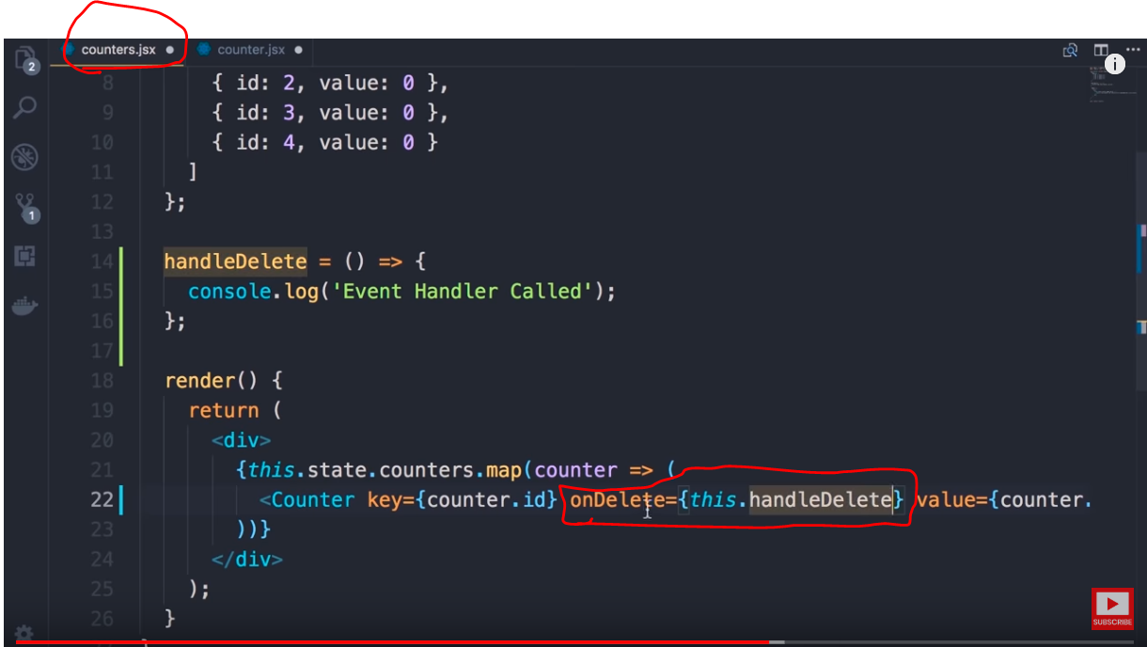 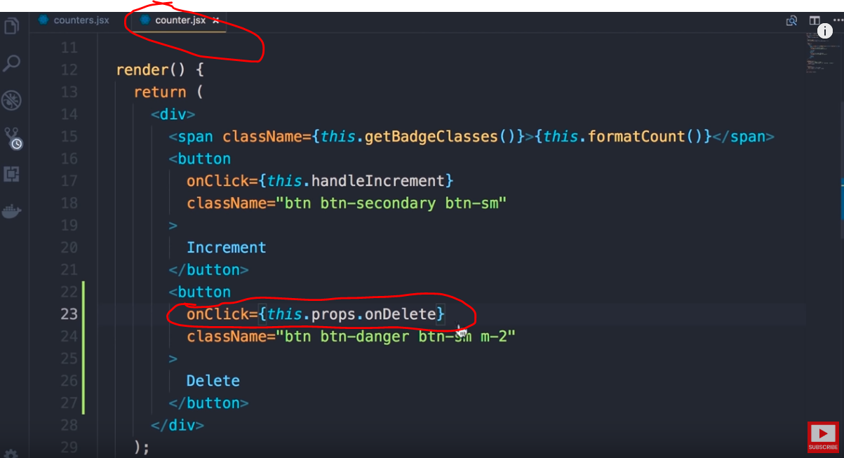

Code

handleDelete = () => {

console.log("Delete event called");

};

Parent component code to udpate

render() {

return (

<div>

{this.state.counters.map(counter => (

<Counter

key={Counter.id}

value={counter.value}

onDelete={this.handleDelete}

/>

))}

</div>

);

}

Child component code to update

<button

className="btn btn-danger btn-sm m-2"

onClick={this.props.onDelete}

>

Delete

</button>

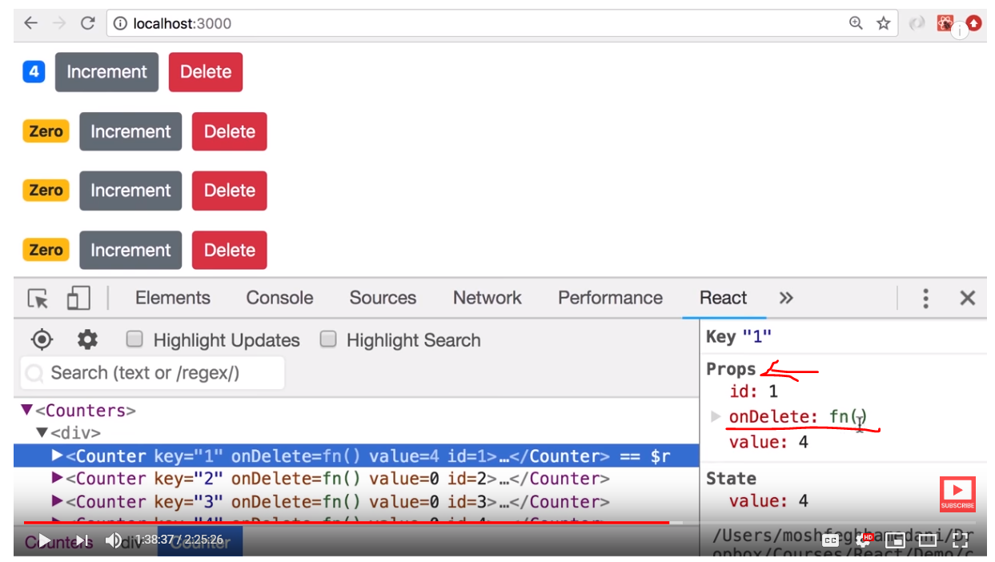

In the next section we will do the actual delete



As we need say exactly which child is raising the delete event we need add below arrow function with the id

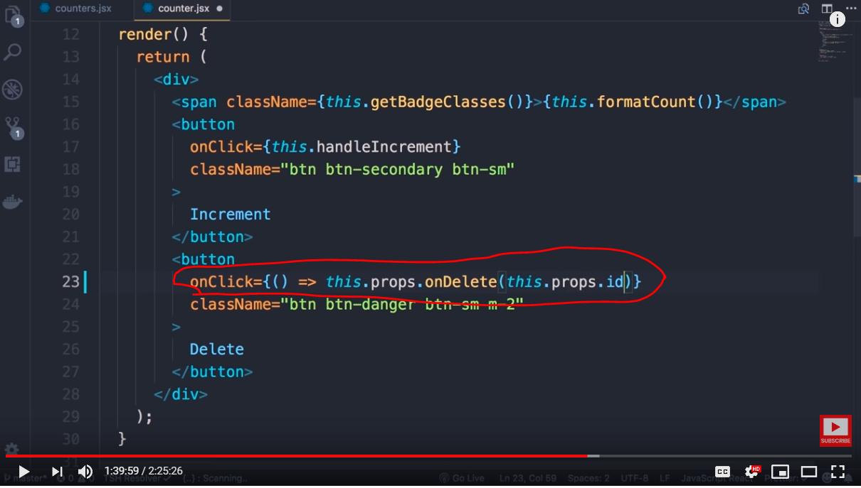 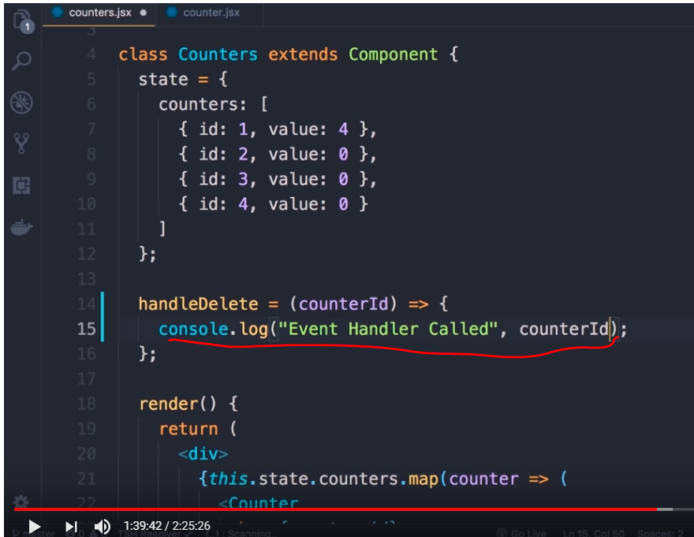

Code ( Parent)

Add id field

render() {

return (

<div>

{this.state.counters.map(counter => (

<Counter

key={counter.id}

**id={counter.id}**

value={counter.value}

onDelete={this.handleDelete}

/>

))}

</div>

);

}

Child code – pass the Id of the child

<button

className="btn btn-danger btn-sm m-2"

onClick={() => this.props.onDelete(this.props.id)}

>

Delete

</button>

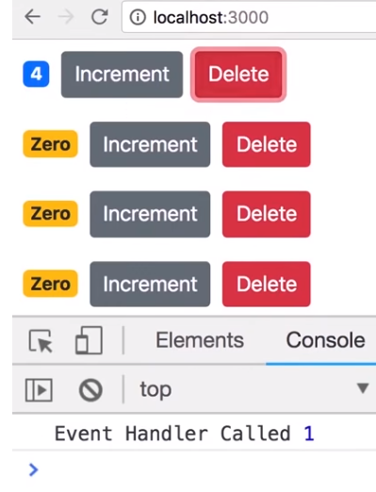

Doing the actual delete using below code change , as we can not modify the state directly we need to use setState method with new state to change

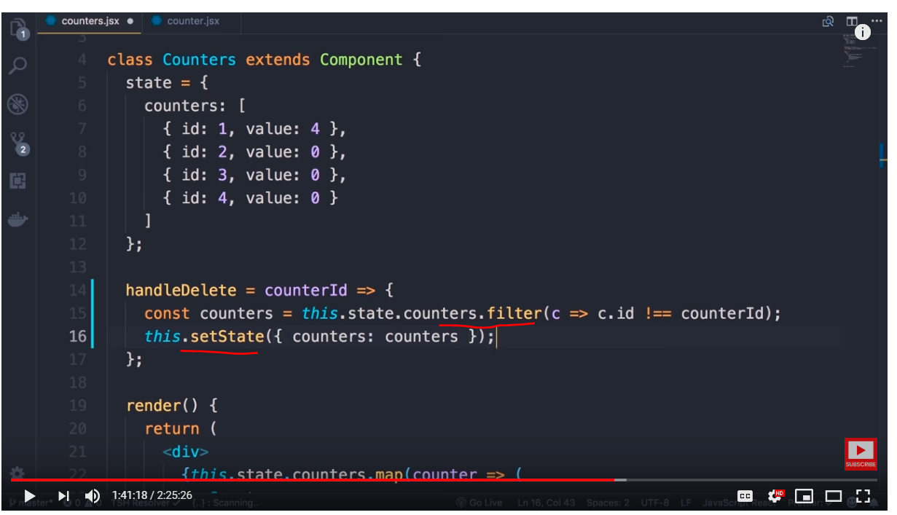

Code – handle delete

handleDelete = counterId => {

console.log("Delete event called", counterId);

const countersNewState = this.state.counters.filter(

cts => cts.id != counterId

);

this.setState({ counters: countersNewState });

};

Next topic

If we observer we are using both key and id , key is used for internal purpose and not passed to prop and id is

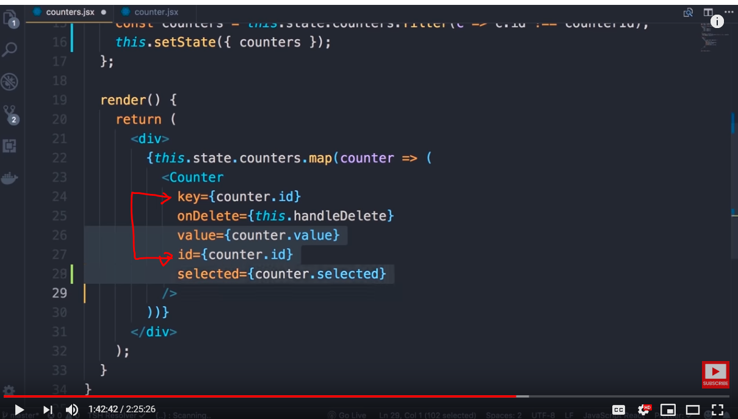

As we can see based on the need the number attributes and respective values assigned to a component could increase. It would look ugly, the whole point of object is to use encapsulation

We can replace all the properties( attributes) into a single object as below and in future if we add more properties we don’t need to modify the HTML, our counter object is carrying all the data about the counter

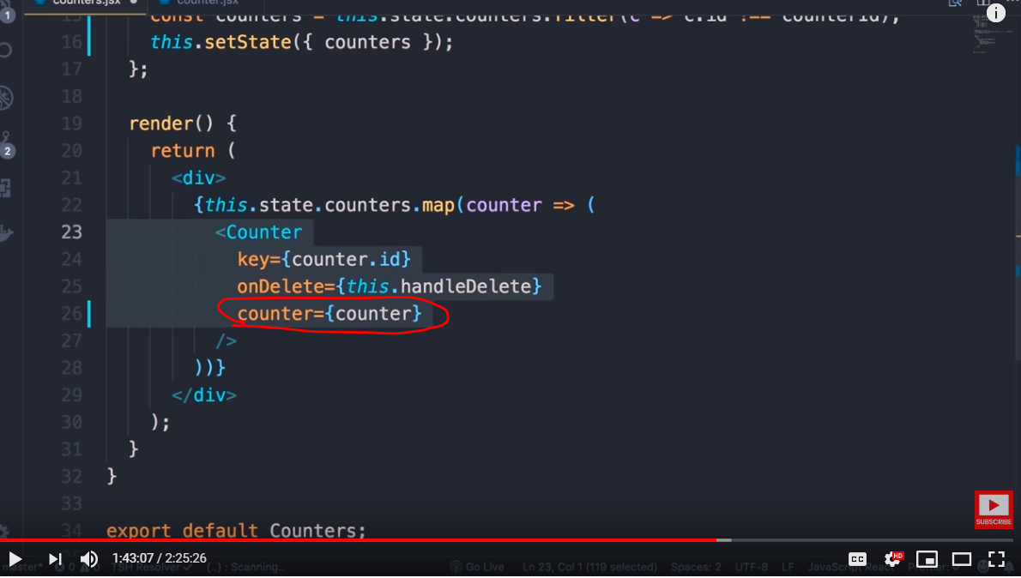

Make below changes in the child component which receives the entire counter object as input to props instead of individual fields

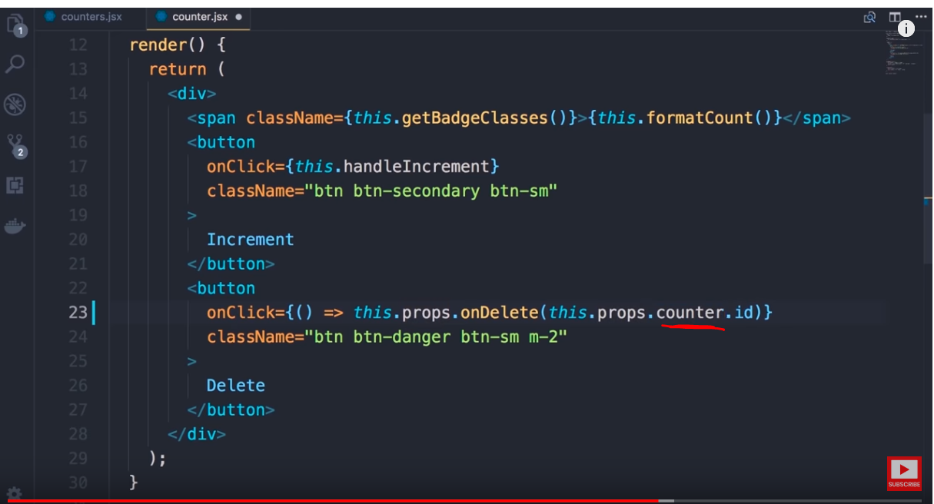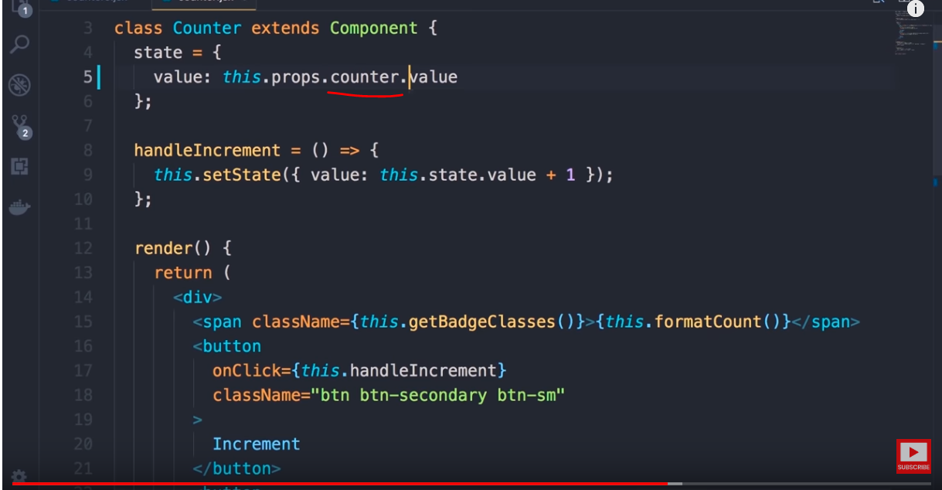



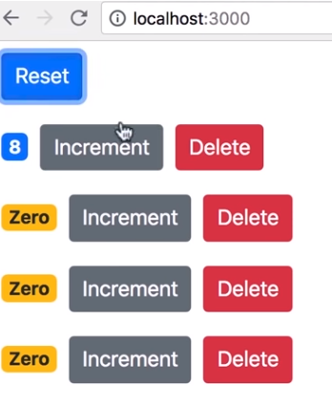

1. When we click on increment, we can access local state and increase the counter value
2. But when we click on reset button we can not reset the counters of all counters as we do not have access to the state of the child components
3. In order to achieve this we need to remove local state and have a single source of truth

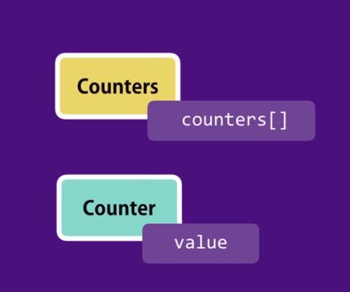 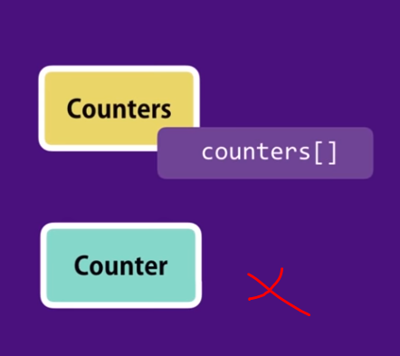

Add reset button code

<button className="btn btn-primary btn-sm m-2">Reset</button>

Add reset handler

handleReset = () => {

const countersResetState = this.state.counters.map(cts => {

cts.value = 0;

return cts;

});

this.setState({ counters: countersResetState });

};

<button

className="btn btn-primary btn-sm m-2"

onClick={this.handleReset}

>

Reset

</button>

The reason fot his is because we don’t have single source of truth , parent has its soruce of data and child has its soruce of data, parent can not modify child state

The state of child is disconnected from parent’s state.

To fix this problem , we need to remove local state



Remove local state and pass the data from parent, such components are called controlled component which are completely controlled by parent and can only raise events

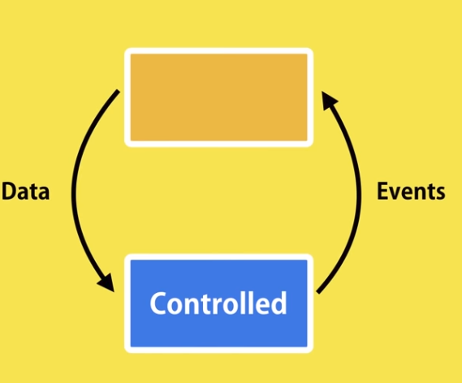

Remove local state and all references to local state

* Remove local state
* References to state object to be changed to use props , like below
* this.props.counter.value
* Remove handleIncrment menthod , it will be taken care by parent
* Make below Code change in child component

<button

onClick={() => this.props.onIncrement(this.props.counter)}

className="btn btn-secondary btn-sm"

>

Increment

</button>

Now we are relying enitely on props , data passed by parent

Now implement the handler in parent component, though it clones the state but modification is directly reflected to the state but not in DOM , which is a no no in react , we need to use setState to modify

handleIncrement = counter => {

console.log(counter);

const counterForIncrement = [...this.state.counters];

counterForIncrement[0].value++;

console.log(this.state.counters[0]);

};

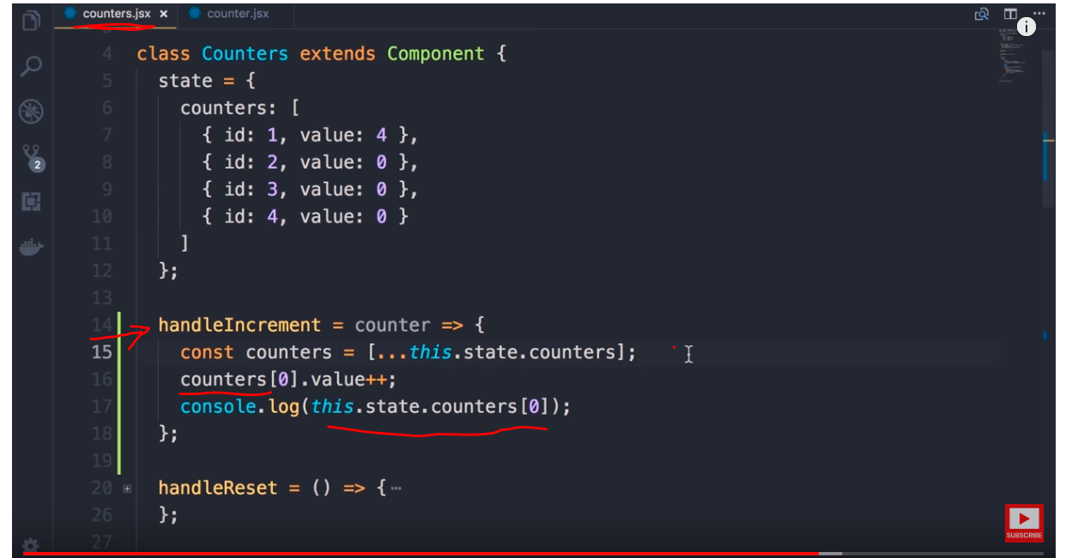 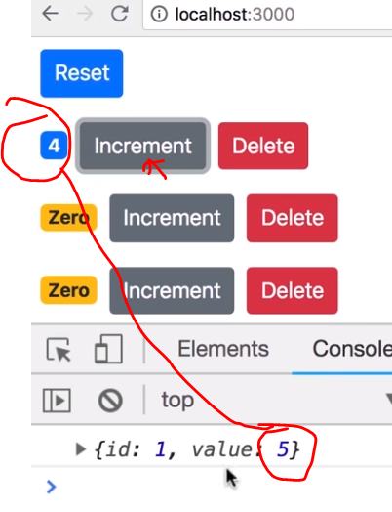

Final code which works for any counter is below

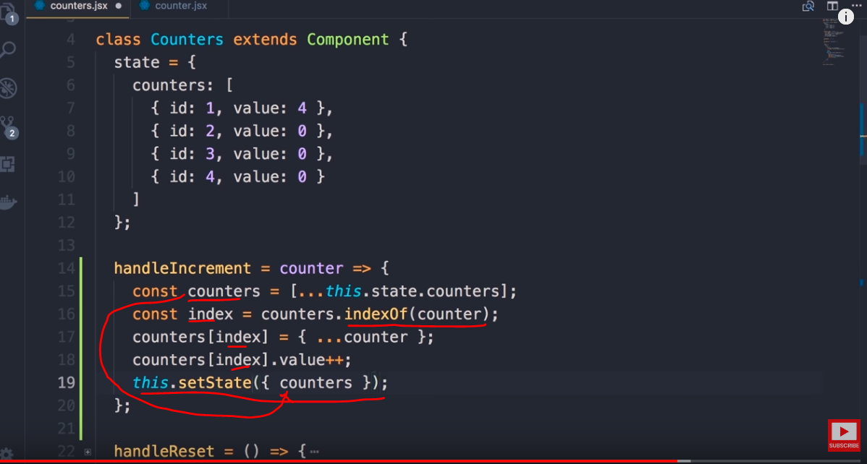 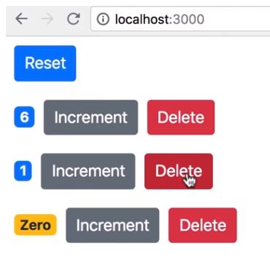

Code

handleIncrement = counter => {

console.log(counter);

const counterForIncrement = [...this.state.counters];

const index = counterForIncrement.indexOf(counter);

counterForIncrement[index] = { ...counter };

counterForIncrement[index].value++;

console.log(this.state.counters[index]);

this.setState({ counters: counterForIncrement });

};



Let’s create a NAV bar component to have total count

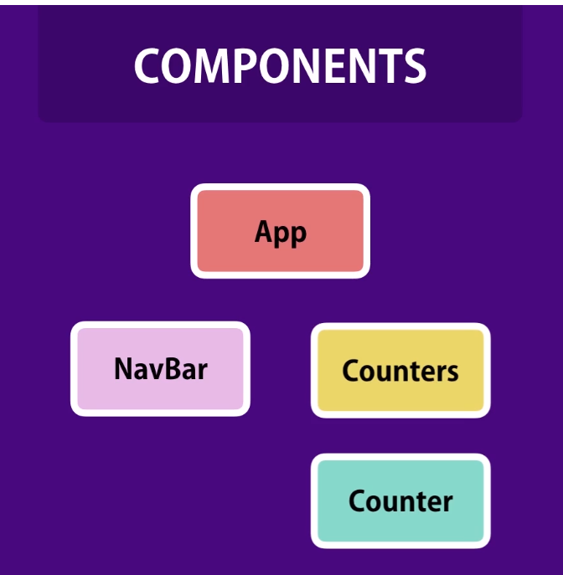

Create a Navbar.jsx component with below code

import React, { Component } from "react";

class Navbar extends Component {

state = {};

render() {

return (

<nav className="navbar navbar-light bg-light">

<a className="navbar-brand" href="#">

Navbar

</a>

</nav>

);

}

}

export default Navbar;

change the app.js to include below code

import NavBar from "./components/navbar";

import Counters from "./components/counters";

function App() {

return (

<React.Fragment>

<NavBar />

<Counters />

</React.Fragment>

);

}

Update index.js to have <App/> component

ReactDOM.render(<App />, document.getElementById("root"));

* Earlier we passed data from parent “Counters” component to child “counter” component via props
* There is no parent child relationship between counters and navbar component
* How can display total count in navbar when there is no parent child relationship
* In situations like this we need to lift the state up

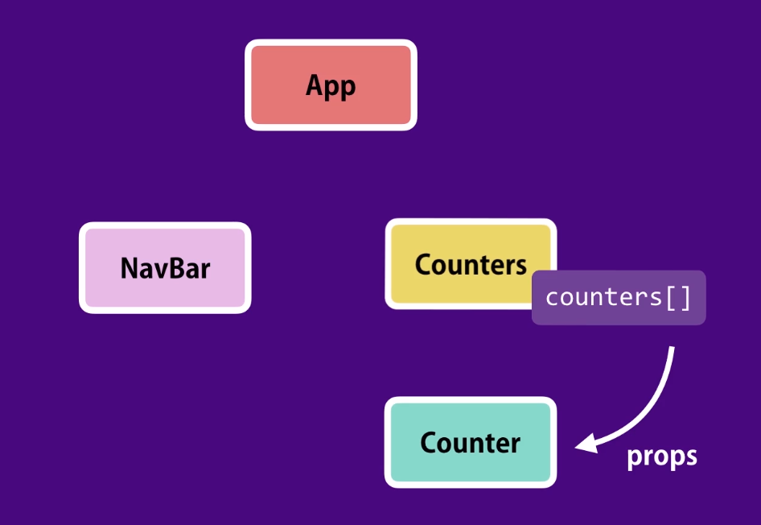

After lifting the state up we will be able to pass counters array to all the children using props

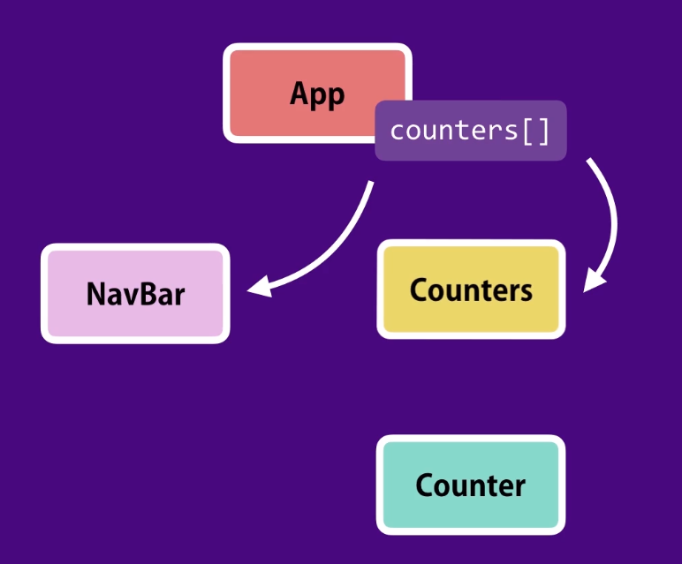



First we need to cut the state and all handlers from counters component to app component

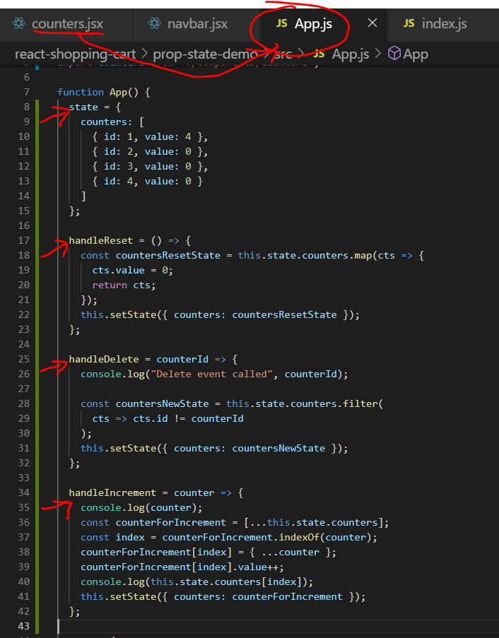

In app component include below code for counters component to raise event

<Counters

onReset={this.handleReset}

onDelete={this.handleDelete}

onIncrement={this.handleIncrement}

/>

Make below changes in counter component

Note : counters component acts as a event bubbler

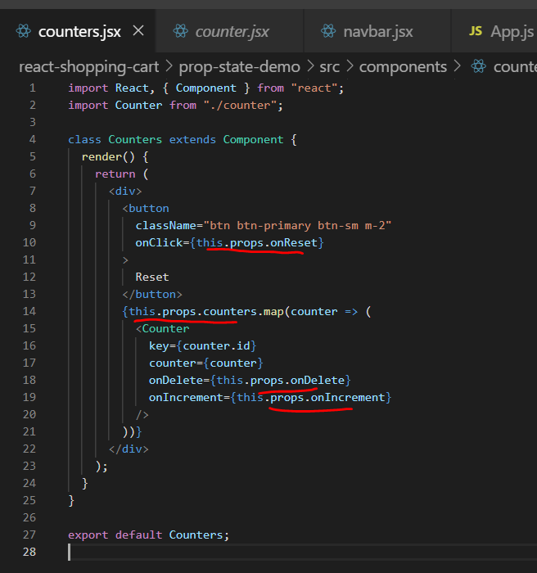

Notice we are not passing counters[] data to from App to counters component yet , lets do that

<Counters

counter={this.state.counters}

onReset={this.handleReset}

onDelete={this.handleDelete}

onIncrement={this.handleIncrement}

/>

Finally counters component gets data and handlers both from parent component

Next Step : to display total counters in navbar add below as input to navbar

<NavBar totalCounters={this.state.counters.length} />

In the nav bar component print the totalCounters

<a className="navbar-brand" href="#">

Navbar{" "}

<span className="badge badge-pill badge-secondary">

{this.props.totalCounter}

</span>

</a>

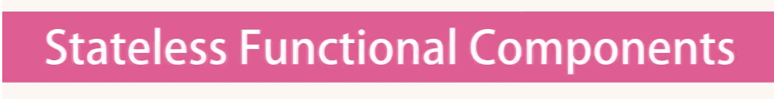

We can convert the Navbar implementation into a stateless function

const Navbar = props => {

return (

<nav className="navbar navbar-light bg-light">

<a className="navbar-brand" href="#">

Navbar{" "}

<span className="badge badge-pill badge-secondary">

{props.totalCounters}

</span>

</a>

</nav>

);

};